BreathRIPple User Manual

Information

The BreathRIPple software was developed for use by Dr. Clement L. Ren, MD, MBA, ATSF at Riley Children’s Hospital, to fulfill the requirements of Biomedical Engineering Design, the capstone course of the undergraduate Biomedical Engineering program at Indiana University Purdue University Indianapolis. The software is open-source and available at <https://github.com/rsurridg/breathRIPple>. Development requests and bug reports can be submitted to Rachel Surridge at rsurridg@iu.edu.

Required Resources

[BreathRIPple Software](https://github.com/rsurridg/breathRIPple)

BioRadio 150 (Available from Great Lakes Neurotechnologies)

[BioCapture Software](https://www.dropbox.com/sh/9loepvr1iw2syiy/AADEjc77_D-qqufE80InewNva?dl=1) (Compatible with BioRadio 150: Version 4.2 or earlier)

[BioRadio Jumper Cables](https://glneurotech.com/bioradio/inventory/?model_number=115-0065) (2x)

RIP Band Interface Cables ([Chest](https://glneurotech.com/bioradio/inventory/?model_number=501-0195) and [Abdomen](https://glneurotech.com/bioradio/inventory/?model_number=501-0194))

[RIP Bands](https://glneurotech.com/bioradio/inventory/?model_number=501-0184) (2x)

Optional Resources

[Great Lakes Neurotechnologies RIP QuickStart Guide](http://glneurotech.com/docrepo/quick-notes/Note_BioCaptureRIP_final.pdf)

MATLAB 2020a

* Windows 10 or macOS Catalina/Mojave/High Sierra
* Any Intel or AMD x86-64 processor
* Minimum 4 GB of RAM
* Minimum 8 GB HDD space
* [See more at MathWorks.com](https://www.mathworks.com/support/requirements/matlab-system-requirements.html)

Installing BreathRIPple Software

The BreathRIPple software is available on GitHub as both a MATLAB app and a standalone executable.

If you have a copy of MATLAB installed:

Go to <https://github.com/rsurridg/breathRIPple> and click Clone or Download > Download ZIP.

Unzip the folder in your file explorer.

Double-click BreathRIPple.mlappinstall in the main directory. This will start MATLAB and install the BreathRIPple app. The app will appear in the App Gallery (Apps tab). Click the icon in the App Gallery to launch BreathRIPple.

If you do not have a copy of MATLAB installed:

Go to <https://github.com/rsurridg/breathRIPple> and click Clone or Download > Download ZIP.

Unzip the folder in your file explorer.

Double-click BreathRIPpleInstaller.exe.

This will launch an installation screen. You will be prompted to install the MATLAB Runtime Compiler (MCR) along with the BreathRIPple software if you do not already have a copy on your machine. MCR does **not** require a license to install.

Launch BreathRIPple using your search bar or programs list.

Recording and Entering Sleep Status

If you have already recorded a RIP trace in BioCapture and wish to analyze it, please proceed to Exporting from BioCapture and Uploading to BreathRIPple.

Note: There is currently no way to interpret or receive sleep status information associated with a previously recorded RIP signal. Sleep status can only be gathered from the user during live recording. Software development requests can be made to Rachel Surridge at rsurridg@iu.edu.

The BreathRIPple Recording Screen

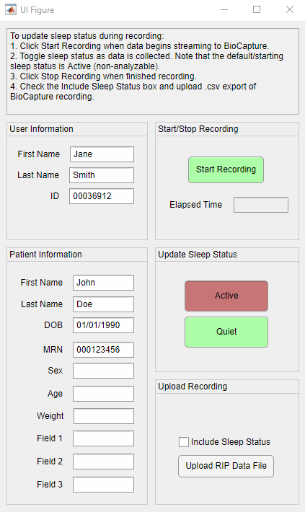

Figure 1: The recording screen is displayed when the BreathRIPple app is launched. This is where the user can enter information about the patient and their sleep status during recording.

If you wish to associate patient information with the analysis, fill in the patient and user fields. Any/all of these fields can be left blank, unless patient information is provided without user information. If patient information is associated with the data, user information of the health professional operating the software must also be provided to create a responsible person for protected health information.

Launch BioCapture side-by-side with the BreathRIPple Recording Screen.

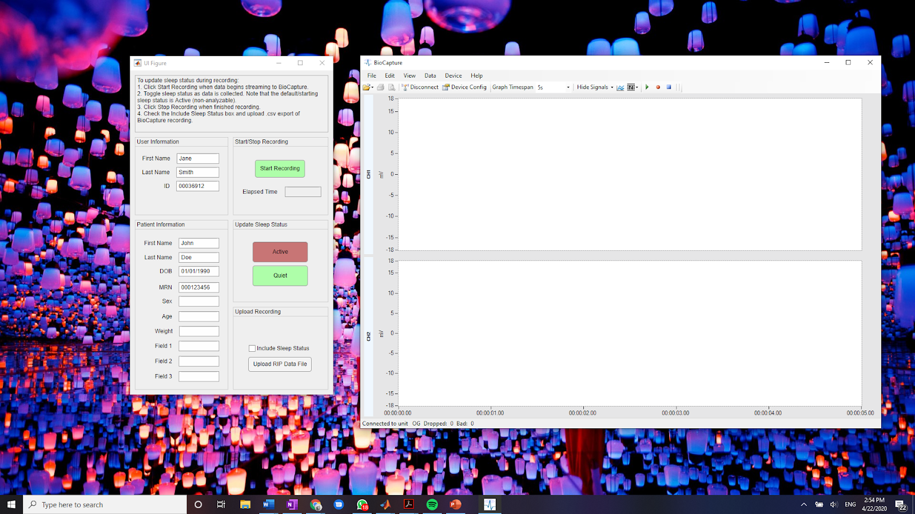

Figure 2: BreathRIPple and BioCapture side-by-side.

If desired, configure BioCapture for RIP recording via the Device Config button prior to recording. The RIP QuickStart Guide provided by GL Neurotechnologies gives suggestions for device configuration. For instructions on how to attach the bands, interface cables, and jumper cables to the patient and BioRadio, as well as connect the BioRadio to BioCapture for streaming, reference the RIP QuickStart Guide listed in Optional Resources and the BioRadio user manual. This document assumes working knowledge of the BioRadio/RIP/BioCapture system.

Note: The use of a noise filter in BioCapture is not necessary, as BreathRIPple utilizes a low-pass filter to eliminate noise prior to analysis.

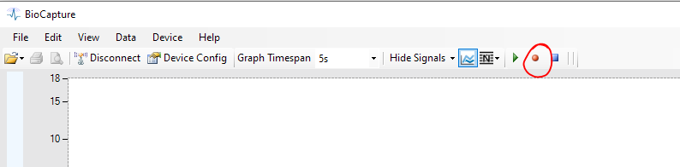

Figure 3: The Toggle Recording button in BioCapture.

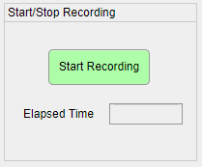

Figure 4: The start/stop recording interface in BreathRIPple before a recording has been initiated.

When ready to record, press the red Toggle Recording button in BioCapture and select a destination for the .bcr file. As soon as data begins streaming from the BioRadio, hit Start Recording in BreathRIPple. The order in which you start the recordings is unimportant, but the actions should take place within a few seconds of each other.

**Setting Sleep Status**

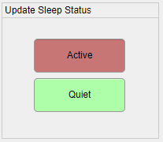

Figure 5: Toggle buttons for setting sleep status during live recording of RIP signals.

The sleep status of the patient can be toggled in the Update Sleep Status section of the Recording Screen. Note that the default/starting sleep status is Active (non-analyzable). When the patient enters quiet sleep, toggle Sleep Status from Active to Quiet. The darker, recessed button should represent the current sleep status at all times. Each time the button is toggled, the change in sleep status is saved and timestamped. Only data collected during periods of Quiet Sleep will be analyzed for parameters of interest (phase angle, respiratory rate, etc).

**Ending the Recording**

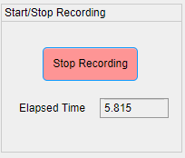

Figure: The start/stop recording interface in BreathRIPple after a recording has been initiated.

To stop a recording, press the Stop Recording button in BreathRIPple and immediately press the Stop Acquisition button in BioCapture. The order in which you halt the recordings is unimportant, but the actions should take place within a few seconds of each other.

The .bcr file recorded by BioCapture will be saved in the location you specified when you began recording. You will need to open this file and export it as a .csv file before uploading it to BreathRIPple. The sleep status information that was just entered into BreathRIPple during the live recording will be associated with the next data file that is uploaded.

Exporting from BioCapture and Uploading To BreathRIPple

To export a recorded RIP signal from BioCapture, File > Open > Recording.

Select the .bcr file containing the data you would like to export.

Then select Data > Export.

The following interface appears:

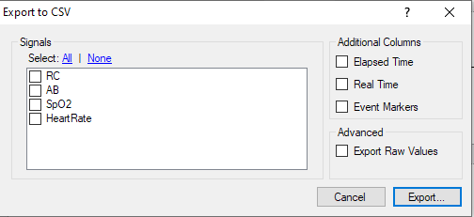

Figure 6: BioCapture’s export options. Available signals and their names will vary depending on the configuration of the BioRadio when the data was recorded.

From the Signals section, select the RC and AB RIP signals **only\***, and check the box next to **Elapsed Time** in the Additional Columns section. Press Export. Export will be a .csv file format. A dialog box will appear when export is complete. This may take several minutes and the software may appear unresponsive during this time.

**\*Note:** Names of signals will vary depending on how the BioRadio was configured when the data was recorded. Select only the signals which were recorded from the chest and abdominal RIP bands.

Return to BreathRIPple Recording Screen.

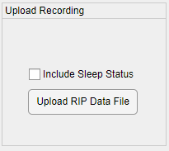

Figure 7: The Upload Recording section of BreathRIPple’s Recording Screen. Sleep status checkbox must be checked in order to utilize sleep status information collected via the protocol above.

To include sleep status information gathered via the protocol in the previous section (Recording and Entering Sleep Status), check Include Sleep Status in the Upload Recording section. Press Upload RIP Data File and select the .csv file you exported using BioCapture. Data upload may take several minutes. When upload is complete, BreathRIPple’s data analysis screen will launch.

Viewing Analysis of a Recording

The BreathRIPple Analysis Screen

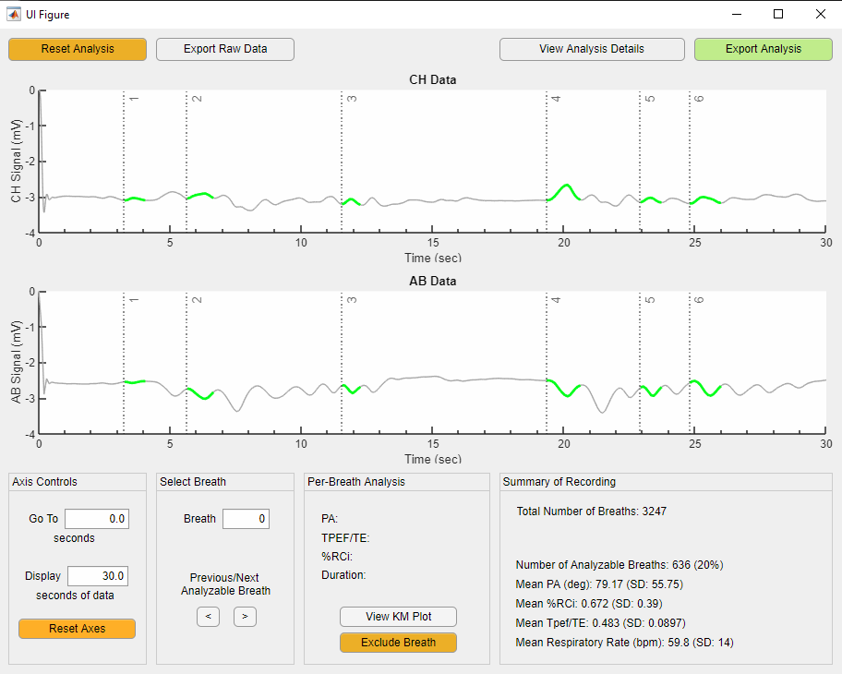

Figure 8: The BreathRIPple analysis screen, which is launched automatically after a file is uploaded to the BreathRIPple Recording Screen.

The Analysis screen:

* plots the full chest and abdominal traces
* provides navigation options
* calculates values of interest for the data
* allows the user to exclude additional breaths from the dataset
* provides analysis details (including quantitative diagnostic calibration)
* offers data export options

The full trace for both the chest and abdomen is plotted in grey. The breaths deemed analyzable by the algorithm’s criteria are highlighted in green and numbered at their start index with a vertical dashed line.

The controls on the Analysis screen are summarized below.

**Axis Controls**

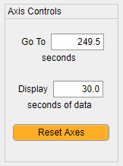

Figure 9: The Axis Controls section of the BreathRIPple Analysis Screen.

The Go To field sets the starting position (in seconds) for both the chest and abdominal axes. The user can also scroll through the data by clicking and dragging on the axes.

The Display Field changes the amount of data (in seconds) that is displayed in a single frame in both the chest and abdominal axes. The default is 30 seconds.

Reset Axes resets the position of both axes to 0 seconds and the width of both axes to 30 seconds.

**Select Breath & Per Breath Analysis**

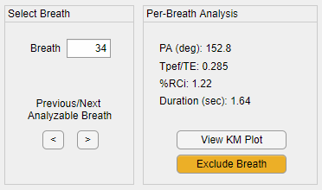

Figure 10: The Select Breath and Per-Breath Analysis sections of the BreathRIPple Analysis Screen.

The Breath field allows to the user to navigate to the position of a specific analyzable breath. The number of the breath corresponds to the dashed, numbered vertical line plotted on the chest and abdominal axes.

Previous and Next buttons allow the user to skip to the next or previous analyzable (green) breath.

The parameters of interest (phase angle, TPEF/TE, %RCi, and Duration) for the breath selected in the **Select Breath** section are displayed in **Per-Breath Analysis**. These values automatically update when the selected breath is changed.

Note: the values displayed in Per-Breath Analysis are not always correlated to the left-most breath displayed on the axes. If you update the axes view using **Axis Controls** or click-and-drag, the selected breath in the **Go To** section will not change. The Per-Breath Analysis always corresponds to the analyzable breath selected in the **Go To** section**.**

The View KM Plot button allows the user to view the Konno-Mead plot (abdomen on the x-axis, chest on the y-axis), which is displayed in a separate window.

The Exclude Breath button allows the user to manually exclude a breath from analysis. Only breaths which are deemed analyzable by the algorithm can be excluded. If the selected breath has already been excluded by the user, this button is automatically converted to a green “Include Breath” button. Pressing it allows a previously excluded breath to be re-included.

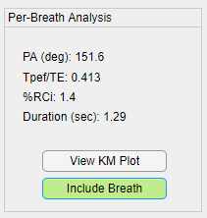

Figure 11: The Per-Breath Analysis section of the BreathRIPple Analysis Screen when an excluded breath is selected.

**Summary of Recording**

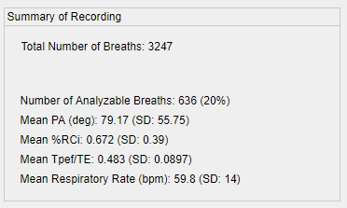

Figure 12: The Summary of Recording section of the BreathRIPple Analysis Screen, which displays mean and SD of parameters of interest.

The Summary of Recording section displays the means and standard deviations of each parameter of interest, as well as information about how many breaths were identified as analyzable by the algorithm, and the total number of breaths identified by the algorithm. This section automatically updates when a breath is manually excluded or re-included from the data.

**View Analysis Details**

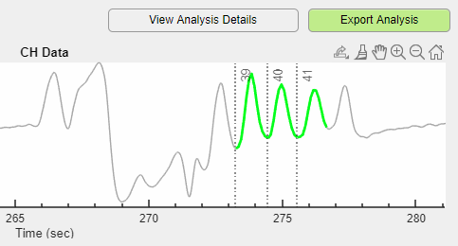

Figure 13: The upper right corner of the BreathRIPple Analysis Screen, highlighting the Analysis Details and Export Analysis buttons.

The button to view analysis details is in the upper right corner of the analysis screen, next to Export Analysis. Pressing this button generates a pop-up summarizing analysis details.

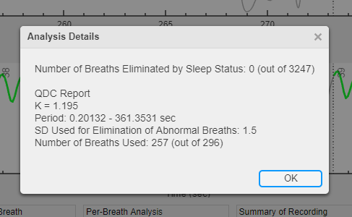

Figure 14: The Analysis Details pop-up, which is displayed when the View Analysis Details button is pressed.

If breaths are eliminated via the sleep status information provided by the user, the number of breaths eliminated is listed here. Details of the quantitative diagnostic calibration (QDC) procedure are also listed, and the calculated K value (the ratio of the chest and abdominal standard deviations) is given. The period is the range of data used for QDC. Number of Breaths Used are the breaths within that period which do not contain data outside the range of the mean +/- 1.5 SD.

**Reset Analysis**

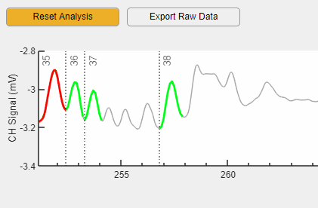

Figure 15: The upper left corner of the BreathRIPple Analysis Screen, highlighting the Reset Analysis and Export Raw Data buttons.

The Reset Analysis button is in the upper left hand corner of the analysis screen. This button reverses all manual exclusion of breaths (turns all red breaths back to green) and resets the axes to their original position. The Summary of Recording is updated accordingly.

Exporting Raw Data

The Export Raw Data button is next to the Reset Analysis button in the upper left corner of the Analysis screen. This exports the elapsed time, chest signal, abdominal signal, and sleep status at full resolution as a .csv. Excel File, .dat, or .txt. This button can be used to associate sleep status information with raw data.

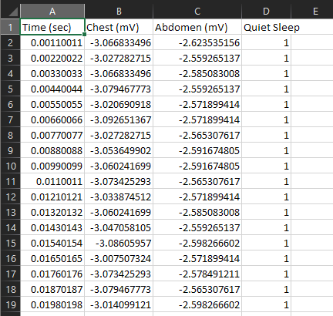

Figure 16: An example of raw data and associated sleep status exported from BreathRIPple via the Export Raw Data button.

Exporting Analysis

The Export Analysis button is in the upper right corner of the Analysis screen. This button exports a summary of the analysis as a .csv. Excel File, .dat, or .txt. An example of the analysis is shown below.

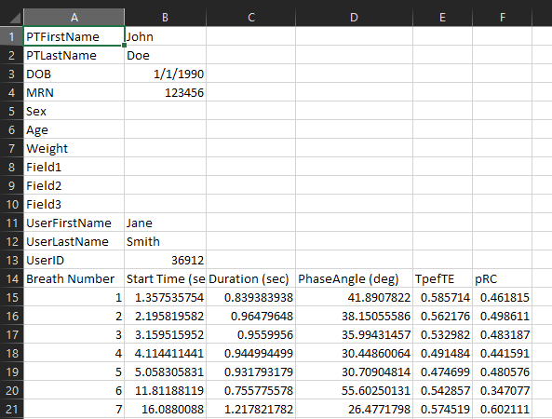

Figure 17: A sample analysis report. Patient information is listed in the first 13 rows. Information about specific analyzable breaths begins on row 15.

The start time, duration, phase angle, TPEF/TE and %RCi for every analyzable breath (plotted in green in the Analysis Screen) is exported to the analysis report. Any breaths that were manually excluded are not included in this report. The header is present in the analysis report even if no patient or user information is provided.